TG-142 Dosimetry Checks on Elekta

# Purpose

This procedure describes how to perform several monthly (or quarterly) dosimetry checks on Elekta-1 or Elekta-2 according to TG-142. This test is part of the TG-142 suite that will replace TG-51, which will now be done annually instead of monthly. Photon beam profile constancy is also used as a double-check when the therapists’ Daily QA3 fails.

# General setup

1. Get the IC Profiler and quad wedges out of the hot lab. The hot lab key is in the cabinet to the right of Kaley’s desk.

## In Elekta treatment room

1. Place the indexing bar at 0 (or somewhere around there). Align the IC Profiler against the indexing bar. The electronics should face away from the gantry.
2. Unplug the DailyQA3 device in the closet and plug the cord into the IC Profiler.
3. Use the hand pendant to set the gantry and collimator angles to zero.
4. Log into Service Mode in the linac software. (You can switch from MOSAIQ by clicking Ctrl+Ctrl+2.)
5. Align the IC Profiler with the x- and y-lasers.

## At Elekta console

1. Start PDI Host if it is not already running.
2. Open SunCheck.
3. Click the **SNC Routine™ Dashboard** button.

T:\Physics - T\PROCEDURES\Images for Procedures\SunCheck\SNC Routine Dashboard button.png

1. Under **Elekta-1** or **Elekta-2**, click the **Run** button for the **Monthly – Dosimetry** template.

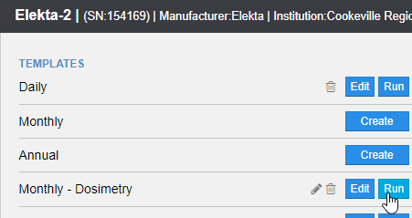

1. If you do not see a notification that background is being collected, click the **Nav** button in the toolbar on the left. Wait for background to be collected.

# Light/rad coincidence

## At Elekta console

1. In SunCheck, note the field size for the light/rad coincidence test.

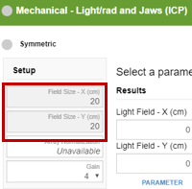

1. Fill in this field size in the **Light Field - X (cm)** and **Light Field - Y (cm)** fields.

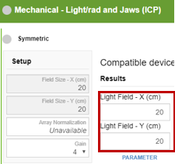

## In Elekta treatment room

1. In the linac software, on the **MLC** tab, set the proper field size.
2. Press the DIST button on the hand pendant to turn on the optical distance indicator (ODI). Use the ODI to set the IC Profiler to the proper SSD.
3. If you will be performing any other photon tests, you may go ahead and place the photon quad wedges (gold color) on top of the IC Profiler. Ensure that an ear shape on the IC Profiler is visible in each hole on the quad wedges. Note that the quad wedges are not necessary for the light/coincidence test.

## At Elekta console

1. In the linac software, on the **Radiation** tab, set the type to x-rays, the energy to 6MV, and the MU to 20.
2. Click **Confirm**.
3. Press the green **MV** button on the Elekta console to deliver beam.
4. When beam finishes, review the measurements in SunCheck. Each tolerance should be green or yellow. Red indicates failure.

# Photon beam profile constancy

## In Elekta treatment room

* 1. Press the DIST button on the hand pendant to turn on the optical distance indicator (ODI). Use the ODI to set the IC Profiler to the proper SSD.
  2. If you did not already do so, place the photon quad wedges (gold color) on top of the IC Profiler. Ensure that an ear shape on the IC Profiler is visible in each hole on the quad wedges.

## At Elekta console

* 1. In SunCheck, note the MU, SSD, field size, and dose rate for the photon constancy test.

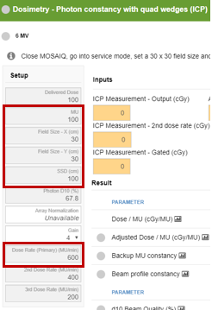

* 1. In the linac software, set the MU, field size, and dose rate noted in the previous step. Set the radiation type to x-rays.
  2. Set the energy to 6 MV. Click **Confirm**.
  3. If the **Activate QA Task** button is visible under the photon constancy test in SunCheck, click it.
  4. Click inside the **ICP Measurement - Output (cGy)** field. Click **Start**.

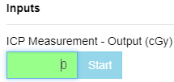

* 1. Press the green **MV** button on the Elekta console to deliver beam.
  2. When beam finishes, click **Stop** in SunCheck.
  3. Review the measurements in SunCheck. Each tolerance should be green or yellow. Red indicates failure. If any test fails, you may review the beam profile constancy graphs.
  4. Repeat steps (e)–(j) for 10MV and 18MV.

# Electron beam profile constancy

1. In SunCheck, note the MU, cone size, SSD, and dose rate for the photon constancy test.

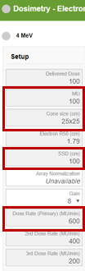

1. In the linac software, set the MU and dose rate noted in the previous step. Set the radiation type to electrons.

## In Elekta treatment room

**Note:** CRMC does not have a 25×25 cone. Use a 20×20 cone with 118.75 instead of 100 SSD. **Note 2:** The baseline for 4MeV has not been set, so the 4MeV test will raise an error.

1. Insert the cone into the gantry. Do not insert a cutout.
2. Do one of the following to adjust the SSD:
   * + If the SSD is already set to 100, it is easiest to set it to 118.75 by lowering the couch. Note the couch height (**Hgt.** field) on the linac monitors. Use the hand controls to lower the couch until the height is approximately (current height) + (118.75 – 100).
     + Press the DIST button on the hand pendant to turn on the optical distance indicator (ODI). Use the ODI to set the IC Profiler to the proper SSD.

## At Elekta console

1. In the linac software, set the energy to 4MeV. Click **Confirm**.
2. If the **Activate QA Task** button is visible under the photon constancy test in SunCheck, click it.
3. Click inside the **ICP Measurement - Output (cGy)** field. Click **Start**.



1. Press the green **MV** button on the Elekta console to deliver beam.
2. When beam finishes, click **Stop** in SunCheck.
3. Review the measurements in SunCheck. Each tolerance should be green or yellow. Red indicates failure. If any test fails, you may review the beam profile constancy graphs.
4. Place the electron quad wedges (black color) on top of the IC Profiler. Ensure that an ear shape on the IC Profiler is visible in each hole on the quad wedges. Note that 4MeV will not work with the quad wedges!
5. Repeat steps (f)–(j) for 6MeV, 9MeV, 12MeV, 15MeV, and 20MeV.

# General wrap-up

## In Elekta treatment room

* 1. Unplug the IC Profiler and plug in the DailyQA3 device.
  2. Log back into Clinical Mode if the therapists will be using the machine again today.
  3. Restore the table setup to the way it was when you entered the room. Lower the table completely.

## At Elekta console

* 1. In SunCheck, click **Save**, **Confirm**, and **OK**.



* 1. Close out of SunCheck and PDI Host.

## In Physics

* 1. In “Physicist Periodic QA Checklist Cookeville <year>,” check off **Dosimetry and Beam Profile Checks (IC Profiler)** for the appropriate machine.